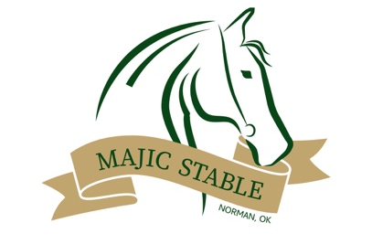

We are so excited that have you at Majic Stable in Norman, Oklahoma. Please read the following policies before attending your first lesson.

o Payment for lessons is due by the first lesson of each month. A $10.00 late fee can be applied for late payment.
o Majic does not do makeups or monetary credit for missed lessons. If you miss a lesson, you still must pay for that lesson to hold the spot. This ensures that we can keep well qualified instructors for our riders. If Majic cancels a lesson, a makeup or credit will be offered.
o Once payment for a month of lessons is made, no refunds will be given. If a rider wishes to terminate lessons at the beginning of a month, it must be done before paying the monthly fee and a minimum of 2 weeks notice must be texted to Sarah at 405-503-3980.
o Parents should not be in the crosstie area or barn. We need to keep those areas as open as possible, and riders need to be able to focus with the instructors during saddling and unsaddling.
- Parents can come watch the last half of one lesson per month. We want parents to see the progress that riders are making, but we also need to be able to focus during classes.
Thank you

